I belong to a small village of Odisha, India where frequent power cut is very common. It hampers the life of every one. During my childhood days continuing studies after dusk was a real challenge. Due to this problem I designed a solar system for my home on a experimental basis. I used a solar panel of 10 Watt, 6 V for lighting few bright LEDs. After facing a lot of hardships the project was successful. Then I decided to monitor the voltage, current, power & energy involved in the system. This brought the idea of designing an Energy Meter. This brought the idea of designing an ENERGY METER. I used ARDUINO as the heart of this project because it is very easy to write code in its IDE and there are huge numbers of open source library available in the internet which can be used according to the requirement. I have experimented the project for very small rated (10 Watt) solar system but this can be easily modified to use for higher rating system.

Feature:

Energy monitoring by

1. LCD display
2. Via internet (Xively upload)
3. Data logging in a SD card

STEP 1: Parts Required:

1. ARDUINO UNO
2. Arduino Ethernet Shield
3. 16x2 Character LCD
4. ACS 712 Current sensor
5. Resistors (10k, 330 ohm)
6. 10K Potentiometer
7. Jumper wires
8. Ethernet cable
9. Bread Board

STEP 2: Power and Energy

Power:

Power is product of voltage (volt) and current (Amp)

$$P = V×I$$

The unit for power is Watts or K W

ENERGY:

Energy is the product of power (Watts) and time (Hour)

$$E=P×t$$

Unit of energy is Watt Hour or Kilowatt Hour (kWh)

From the above formula is clear that to measure Energy wee need three parameters

1. Voltage
2. Current
3. Time

STEP 3: Voltage Measurement

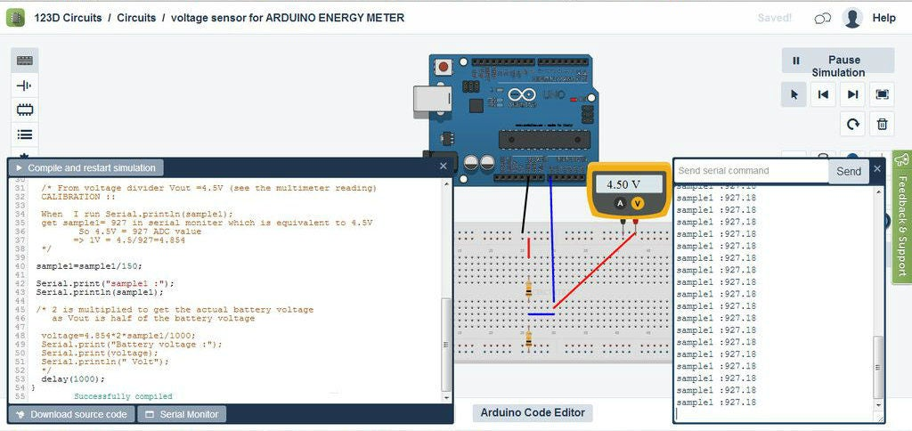

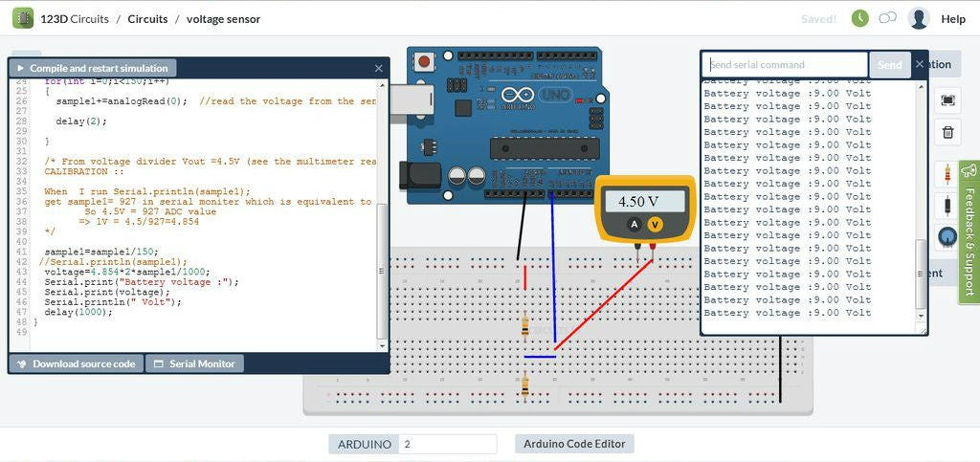

Voltage is measured by the help of a voltage divider circuit. As the ARDUINO analog pin input voltage is restricted to 5V I designed the voltage divider in such a way that the output voltage from it should be less than 5V. My battery used for storing the power form the solar panel is rated 6V, 5.5 Ah. So, I have to step down this 6.5V to a voltage lower than 5V.

I used R1=10k and R2=10k. The value of R1 and R2 can be lower one but the problem is that when resistance is low, the higher current flow through it as a result large amount of power ($P=I^{2}R$) dissipated in the form of heat. So different resistance value can be chosen but care should be taken to minimize the power loss across the resistance.

$$V_{out}=\frac{R_{2}}{(R_{1}+R_{2})}*V_{bat}$$

$$V_{bat}=6.5 when fully charged$$

$$R_{1}=10kΩ and R_{2}=10kΩ$$

$$V_{out}=\frac{10}{10+10}∙6.5 V=3.25V$$

3.25V is lower than 5V and suitable for Arduino Analog PIN

NOTE

I have shown 9 Volt battery in bared board circuit is just of example to connect the wires. But the actual battery I used is a 6 volt, 5.5 Ah lead acid battery.

Voltage Calibration:

When battery is fully charged (6.5V) we will get a Vout = 3.25V and lower value for other lower battery voltage.

ARDUINO ADC convert Analog signal to corresponding digital approximation.

When the battery voltage is 6.5V I got 3.25V and lower value for lower battery voltage.

ARDUINO ADC convert Analog signal to corresponding digital approximation. When the battery voltage is 6.5V I got 3.25V from the voltage divider and sample_1= 696 in serial monitor, where sample_1 is ADC value corresponds to 3.25V

For better understanding I have attached the real time simulation by 123D. circuit for voltage measurement.

CALIBRATION:

3.25V equivalent to 696

1 is equivalent to 3.25V/696 = 4.669 mV

Vout = (4.669*sample_1)/1000 volt

Actual battery voltage = (2*Vout) Volts

ARDUINO CODE:

// Taking 150 samples from voltage divider with an interval of 2 sec and then average the samples data collected

for (int = 0; I < 150; i++)

{

Sample_1 = sample_1 + analogRead(A2); //read the voltage from the divider

delay(2);

}

sample_1 = sample_1/150;

voltage = 4.669*2*sample_1/1000;

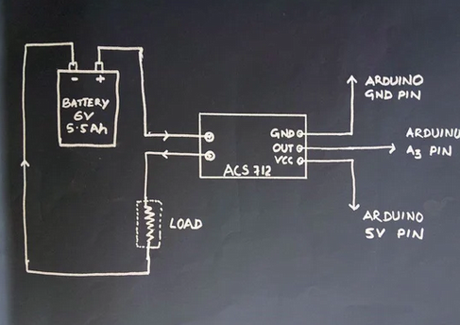

For current measurement I used a Hall Effect current sensor ACS 712 (20 A). There are different current range ACS712 sensor available in the market, so choose according to your requirement. In bread board diagram I have shown LED as a load but the actual load is different.

WORKING PRINCIPLE:

The Hall Effect is the production of a voltage difference (the Hall voltage) across an electrical conductor, transverse to an electric current in the conductor and a magnetic field perpendicular to the current in the conductor and a magnetic field perpendicular to the current.

To know more about Hall Effect sensor, click here.

The data sheet of ACS 712 sensor is found here

From Data Sheet

1. ACS 712 measure positive and negative 20 Amps, corresponding to the analog output 100 mV/A
2. No test current through the output voltage is Vcc/2 = 5V/2 = 2.5V

CALIBRATION:

Analog read produces a value of 0-1024, equating to 0V to 5V

So Analog read 1 = (5/1024) V = 4.89 mV

Value = (4.89*Analog Read value)/1000 V

But as per data sheets offer is 2.5V (When current zero you will get 2.5V from the sensor’s output)

Actual value = (value – 2.5) V

Current in amp = actual value*10

ARDUINO Code:

// taking 150 samples from sensors with an interval of 2 sec then average the samples data collected

for (int i = 0; i<150; i++)

{

sample_2+=analogRead(A3); //read the current from sensor

delay(2);

}

sample_2=sample_2/150;

val=(5.0*sample_2)/1024.0;

actualval=val-2.5; //offset voltage is 2.5v

amps=actualval*10;

STEP 5: TIME MEASUREMENT

For time measurement there is no need of any external hardware, as Arduino itself has inbuilt timer.

The milis() function returns the no of miliseconds since the Arduino board began running the current program.

ARDUINO Code:

long milisec = milis(); // calculate time in miliseconds

long time = milisec/1000; // convert miliseconds to seconds

STEP 6: How ARDUINO CALCULATE POWER AND ENERGY

totamps=tomaps+amps; // calculate total amps

avgamps = totamps/time; // average amps

amphr = (avgamps*time) / 3600; // amp-hour

watt = voltage*amps; // power = voltage*current

energy = (watt*time)/3600; Watt-sec is again convert to Watt-hr by dividing 1hr(3600 sec)